**Report about best devices & OS & programming languages & database and applications.**

**System Name: Task Management System**

1. **Devices :**

**Web Server: To publish the web application and manage the large amount of tasks like” Member name, Email or Role or the other data” and let each user open and use the web application on their local Device.**

**Personal Computers (PCs): Computers with requirements**

**Minimum: CPU: core i3 5th gen Ram: 4GB**

**Minimum: CPU: core i5 8th gen Ram: 8GB and it has to connect to a network**

1. **Operating Systems:**

**Windows: Widely Use Support from Microsoft Support Visual Studio code and Microsoft SQL Server and good for office applications Friendly User Interface Specifically Versions Windows 10/11**

**Macintosh (Mac OS): Friendly User Interface good for Design and squire.**

**Linux / Ubuntu: Open source widely Use Good Security**

1. **Programming Language:**

**Backend:**

**C Sharp (C#): Support ASP.net Core Good for Web Development and desk top Development**

**Structured Query Language (SQL): To create tables and manage the database**

**Frontend:**

**Hyper Text Markup Language (HTML): To create the Basic of the web application**

**Cascading Style Sheet (CSS): To add design and colors For the Web pages**

**Java Script (JS): To Manage the logic of the Web Pages**

1. **Database :**

**Relational Database: Good for organized Data and Relational Database Using SQL & My SQL**

1. **Applications**

**Microsoft Visual Studio Code: to create the Web**

**Application and the database “Code First”**

**Microsoft SQL Server: To create Database, Tables ,Relations Between the tables**

**Design of an integrated system (Class diagram)**

Task

Id

Name

Description

Status

Property

Date time

Member ID

Project ID

+Add ()

+Update ()

+Delete

+Show

Project

Id

Name

Description

Start Date

End Date

+Add ()

+Update ()

+Delete

+Show

Member

ID

NAME

Email

Role

Show ()

Update ()

**ERD:**

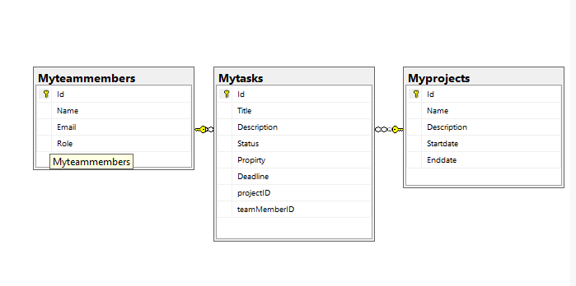

**Testing**

|  |  |  |  |  |  |  |
| --- | --- | --- | --- | --- | --- | --- |
| **Test case ID** | **Test case description** | **Test Steps** | **Test Data** | **Expected Result** | **Actual Result** | **Pass/Fail** |
| 1 | Test Add Functionality for all pages | Click on Add button and insert date in fields | Fill the fields with its datatype and click on submit button | Add Successfully and shows the added Row | Add Successfully and shows the added Row | PASS |
| 2 | Test Update Functionality for all pages | Click on Update button and Update date in fields | Update the fields with its datatype and click on submit button | update Successfully and shows the updated Row | update Successfully and shows the updated Rows | PASS |
| 3 | Test Delete Functionality for all pages | Click on Delete button | No Date  Only click on Delete Button | Delete Successfully and Remove the Row | Delete Successfully and Remove the Row | PASS |